Event Emergency
Management Plan

Volleyball Victoria Schools Cup 1
26th-28th May 2026
State Volleyball Centre
270 Stud Road Dandenong North, VIC, 3175

Event Communications
All events must have a nominated Event Coordinator and a nominated Event Safety Officer

Tournament Director Name:* | Matthew Maiolo
Phone:* | 0447 339 207

Safety Officer Name:* | Matthew Maiolo
Phone:* | 0447 339 207

Other roles that may be required given the size, complexity and nature of the event
Competition Director Name: | Matthew Maiolo
Phone: | 0447 339 207

Stadium Reception: | Dandenong Stadium – South East Leisure
Phone: | (03) 8789 7980

Emergency Assembly Point Locations
Provide location details for all emergency assembly areas, i.e. address or land marks

Assembly Area 1* | Looking out from the stadium, left hand side, 2nd row of carpark
Assembly Area 2 | South end carpark of Dandenong Stadium
Assembly Area 3 | N/A
Assembly Area 4 | N/A

Communication and Coordination
Describe the communications system which will be used between organisers, staff and volunteers. Eg. Two-way radios, mobile phones etc*
Mobile phones will be used

Describe the system to be used for communicating with the general public at your event.
Eg. PA system, megaphone etc*
PA system and megaphone will be used to communicate with public if needed/Exposure Events messaging app

Security and Crowd Management
Will security or crowd control be used for the event? If so, provide company details and contact information. *
Not Applicable

Traffic Management
Are any temporary road closures planned for this event? How will this be managed? *
Not Applicable

How will exhibitors, performers, staff, volunteers and emergency vehicles access the site?*
Use of Stadium Carpark

Lost Persons Procedure
Detail what will happen if a lost child or person is found, where they are taken to, what staff will look after them and how will you locate their parents, guardians or friends.*
Stadium Reception first notified, and then the Tournament Director will be advised. Lost
Person to be taken to Competition office (Home Change room) in the care of Competition Manager

Detail what will happen if a parent or guardian reports a lost child or person? *
Relevant School will be contacted and found inside stadium

Emergency Procedures

Fire
 | Response actions (amend as appropriate)
Discovery of a fire | ☐ Sound fire alarm
Discovery of a fire | ☐ Call 000 to notify the fire brigade
Discovery of a fire | ☐ If safe to do so extinguish the fire
On sounding the alarm | ☐ If threat to life exists, Tournament Director or Safety Officer will lead all persons at event to the designated assembly point(s) immediately
On sounding the alarm | ☐ Walk calmly and quickly and avoid panic
On sounding the alarm | ☐ Ensure attendees with disabilities are assisted
On sounding the alarm | ☐ Check that all areas have been cleared en-route to assembly point(s)
On sounding the alarm | ☐ Ensure all attendees remain at the assembly point(s) until clearance to leave is given
Returning  to the site | Do not return to the building/site until given the all clear by the Fire Service

Gas Leak
 | Response actions (amend as appropriate)
If gas leak is suspected | ☐ Evacuate immediate area
If gas leak is suspected | ☐ Ensure attendees with disabilities are assisted
If gas leak is suspected | ☐ Call 000 to notify relevant Emergency Services
If gas leak is suspected | ☐ Remove ignition sources, only if safe to do so
If gas leak is suspected | ☐ Isolate gas/electricity supply, only if safe to do so
If gas leak is suspected | ☐ If threat to life exists, sound alarm for evacuation
If gas leak is suspected | ☐ Tournament Director or Safety Officer will lead all persons at event to the designated assembly point(s) immediately
If gas leak is suspected | ☐ Check that all areas have been cleared en-route to assembly point(s)
If gas leak is suspected | ☐ Ensure all attendees remain at the evacuation point until clearance to leave is given
Returning  to the site | Do not return to the building/site until cleared by Emergency Services
Medical Emergency
 | Response actions (amend as appropriate)
Incident requiring emergency medical assistance | ☐ Ensure your own safety. Assess area for danger (eg. Live wires, poisonous substances etc)
Incident requiring emergency medical assistance | ☐ If trained, provide first aid
Incident requiring emergency medical assistance | ☐ Call Emergency Services on 000
Incident requiring emergency medical assistance | ☐ Designate someone to meet the emergency services and direct them to the location of the casualty
Incident requiring emergency medical assistance | ☐ Try not to leave the casualty until the emergency assistance arrives
Incident requiring emergency medical assistance | ☐ Do not move casualty unless they are exposed to a life threatening situation

Extreme Weather
 | Response actions (amend as appropriate)
When severe storm threatens | ☐ Monitor Bureau of Meteorology website – www.bom.gov.au
When severe storm threatens | ☐ Secure all items, if safe to do so
When severe storm threatens | ☐ Shut off gas and electricity supply, if safe to do so
Storm approaches | ☐ Tournament Director or Safety Officer to determine if event be cancelled
Storm approaches | ☐ Advise all attendees of cancellation of event
On cancellation of event | ☐ Assist all attendees evacuate the site
On cancellation of event | ☐ If required and available, evacuate everyone to shelter until storm passes

Civil Disturbances
 | Response actions (amend as appropriate)
Disruptive person on-site | ☐ If security in attendance, notify security guard of incident and persons location
Disruptive person on-site | ☐ Contact Emergency Services on 000
Disruptive person on-site | ☐ Remain calm, do not do or say anything that will encourage irrational behaviour
Disruptive person on-site | ☐ If safe, move persons to predetermined safe position to await Police arrival
Bomb Threat
Keep calm. Do not hang up. Without alerting caller, signal co-worker to call 000.

Let the caller talk, ask questions as the opportunity arises and avoid being confrontational
Questions |  |  |  |  | Answers
When is the bomb going to explode?
Where is the bomb?
What does the bomb look like?
What kind of bomb is it?
What is the explosive type and quantity?
Why did you place the bomb?
What is your name?
Where are you?
What is your address?
Exact wording of the threat:
The Caller |  |  |  |  | Answers
Sex: |  |  |  |  | Male Female
Estimated age:
Any speech impairment (specify):
Accent (specify):
Voice – loud – soft etc:
Speech – fast – slow etc:
Manner, calm emotional etc:
Did you recognise the voice? |  |  |  |  | Yes No
If so who do you think it was?
Was the caller familiar with the area? |  |  |  |  | Yes No
Threat Language
Well spoken  Incoherent | Irrational  Taped |  | Message read by caller  Abusive |  |  |  | Other: _____________
Any background noises?
Street noise  House noise | Aircraft  Voices |  | Music  Machinery |  |  | Vehicle  Other: _____________
Call taken
Date: __/___/____ |  | Time: |  | Length of call: |  | Number called:
Fire Danger Period
During the months of October to April fire danger can be extremely high, the Country Fire Authority (CFA) must be consulted if the event is to be conducted on a day of total fire ban or during the fire danger period. Visit the CFA website for further information www.cfa.vic.gov.au

Has a day of total fire ban or fire danger period been considered?* ☐ Yes No

Has the fire service been consulted?* ☐ Yes No

Site Plan
IMPORTANT – It is a requirement that a site plan is developed. On this plan, locate and indicate all of the mandatory points below and any other important items. Tick the items after you have located them on the plan or leave blank if the item is not relevant.

This site plan is essential for emergency management. All staff/participants/performers are to be made aware of the Evacuation Plan and have knowledge of the evacuation procedures as well as a copy of the site plan prior to the event.

Layout of the venue* |  |  | Stage | ☐
Fire Extinguishers |  |  | Walking paths
Emergency assembly points |  |  | Wheelchair access
Vendor stalls |  |  | Coordination Centre | ☐
Emergency exits* |  |  | Audience seating & viewing
Drinking water |  |  | Restricted areas | ☐
First aid* |  |  | Entry & Exit points*
Food & refreshments |  |  | Toilets*
Play grounds | ☐ |  | Parking
Temporary structures | ☐ |  | Emergency vehicle access
Lost and found |  |  | Vehicle access points

Site Plan *

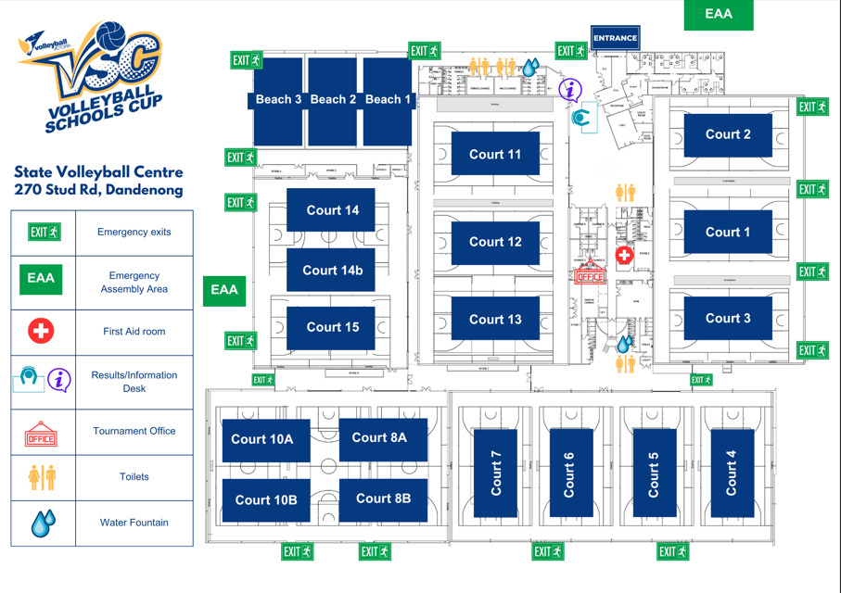

Key Contacts

This list should be used as a quick reference for staff and volunteers at the event, complete all fields relevant to your event.

Position / Organisation | Contact | Phone
Tournament Director* | Matthew Maiolo | 0447 339 207
Safety Officer* | Matthew Maiolo | 0447 339 207
First Aid Officer | Vanessa Kolb | 0407 305 760
Stadium | Reception | (03) 8789 7980
Competition Director | Matthew Maiolo | 0447 339 207
Volleyball Victoria CEO | Kylie Bloodworth | 0449 949 916
Victoria Police |  | 000
Ambulance |  | 000
SES |  | 13 25 00
Vic Roads |  | 13 11 71
CFA |  | 000
Poisons Information |  | 13 11 26
Plumber | Reception | (03) 8789 7980
Electrician | Reception | (03) 8789 7980
Other | Reception | (03) 8789 7980
Declaration

I/we agree to implement the procedures above in case of an emergency and will ensure that all key staff/volunteers will be given a copy of this plan prior to the event, as well as having copies of the plan available on the day of the event.
Applicant Name: | Matthew Maiolo | Organisation: | Volleyball Victoria
Applicant Signature: | M Maiolo | Date: | 21/05/2026

Disclaimer
This has been filled out to the best knowledge of the event. Amendments will be sent to the relevant parties if needed.

