Event Risk Management Plan
Risk Assessment ~ All columns MUST be completed
- Hazard / Source*  List individual tasks or activities | - Risks *  Identify the potential risks associated with each task / activity. | - Risk Rating*  Before Controls  - Low  - Medium  - High  - Extreme | - Risk Controls *  Controls to address identified risks | - Risk Rating *  After Controls  - Low  - Medium  - High  - Extreme | - Responsibility *  Name of person responsible for implementing risk controls
Food | Food poisoning | Medium | - Ensure SEL staff have appropriate food licenses.  - SEL has adequate refrigeration / cooling for their requirements.  - Adequate hand washing facilities are available for staff. | Low | Stadium
Court Surface | Floors slippery due to liquid spill, food spill or sweat | Medium | - No food/drink allowed in halls except water.  - Ensure towels are at each scorebench  - Signage around venue to ensure all spills are wiped up | Medium | Stadium
Venue Set up | Injury due to close set up of courts | Medium | - Apply the Field of Play Layout parameters (Appendix A)  - Nets lowered between courts where possible.  - Signage alerting spectators to be aware of volleyballs leaving the field of play | Low | Stadium, Tournament Director
Game play | Injury during gameplay | Low | - Ensure hazards identified above a mitigated.  - Insurance  - Venue Set Up  - Rules of play | Low | Tournament Director
Lost property | Items being stolen or lost, especially Volleyballs | High | - Branding each Volleyball with VVI  - Complete a ball count at the start and end of each day.  - Ensure match ball comes back to hall supervisor desk with scoresheet so that the next referee or duty team can collect  - Tournament Director to be notified if a ball has been lost  - Lost items to be taken to Tournament Office (Rangers Room) | High | Tournament Director, VV Staff
Financial | Event runs overbudget, profits are less, or event runs into the red | Medium | - Adjust Budget of another competition/event to allow for everything to breakeven | Low | Tournament Director, Operations Manager
Staffing | Staff turn up late or do not arrive at all | Low | - Staff in attendance take on extra tasks where possible  - Staffing plan caters for risk and tasks are resassigned | Low | Tournament Director
Bins | Overflowing bins | Medium | - Schedule cleaners throughout the day of the event to ensure venue cleanliness | Low | Stadium
Game Management | Duty Teams skip completing their duty either without knowledge of duty or on purpose | Medium | - Position a staff member at the exit halfway through the last pool games to sign teams out | Low | Tournament Director, VV Staff
Game Management | Teams do not show up for scheduled game or are late | Medium | - Communication of fixtures to team managers  - Fixtures printed and available throughout the venue  - Follow in accordance with tournament regulations and the game is a forfeit  - Use of Exposure for fixtures | Low | Tournament Director, VV Staff
Safety | Athletes climbing up on the shed roof to retrieve ball that gets stuck | High | - Place signs on the sheds with details of how to retrieve ball | Medium | Stadium, VV staff, Teachers, Spectators

Appendix A – Field of Play
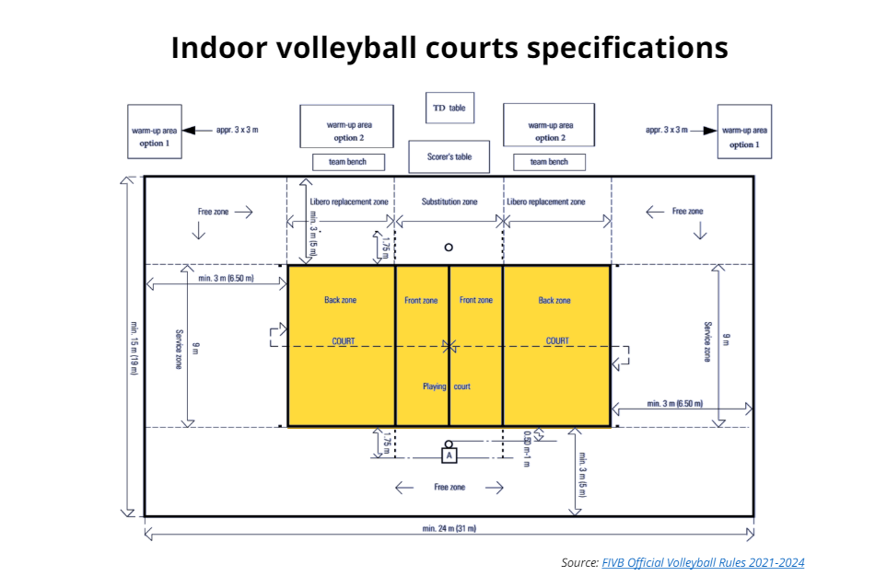

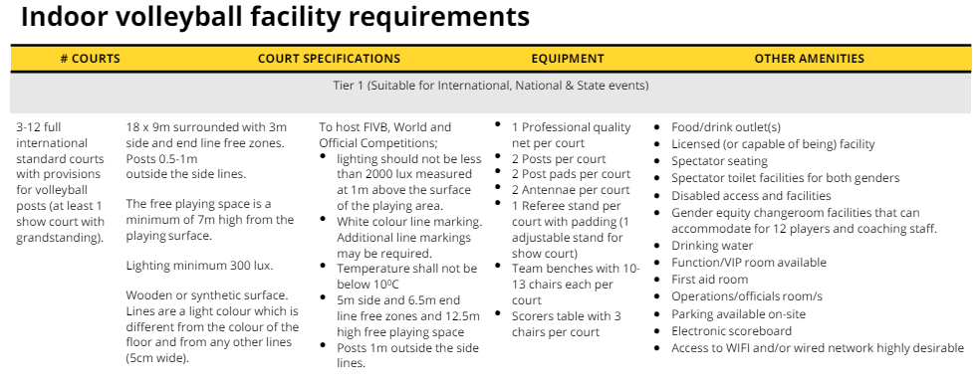

Public Liability Insurance

Have you provided evidence of appropriate Public Liability Insurance for your event? * Own Policy ☐ Cover under Council’s Policy

Have Public Liability Insurance Certificates of Currency been provided from all external parties? * Yes ☐ No

Declaration

I verify that I have, to the best of my knowledge endeavored to anticipate all possible risks relevant to the above event and will ensure all controls listed above are implemented.
Event Organiser: | Matthew Maiolo | Organisation: | Volleyball Victoria Inc
Signature: | M Maiolo | Date: | 19/02/2026

